Synopsis

Automated Credit Risk Categorization for Loan Approval

Problem Id: 08

Student 1 Name: Bhavini Vats
Student 2 Name: Aakriti Chauhan
University Roll number 1: 2028408
University Roll number 2: 2028374
Section: K

- Problem Description:
Financial institutions receive a large number of loan applications every day. Manually evaluating each applicant is time-consuming and prone to human error. Moreover, approving loans to high-risk applicants can lead to financial losses due to loan defaults. Therefore, banks and financial institutions require automated systems to analyze applicant data and predict credit risk.
This project focuses on building a Machine Learning based system that automatically categorizes applicants into risk groups for loan approval. The system will analyze factors such as Credit Score, Annual Income, and Debt-to-Income Ratio to determine whether an applicant is likely to default on a loan.

- Steps of Implementation:

1. Applicant Profiling
Applicant profiling involves analyzing and understanding the dataset containing information about loan applicants. In this step, important features such as credit score, annual income, and debt-to-income ratio are examined. Basic exploratory data analysis techniques like viewing sample data, checking data types, and analyzing class distribution are performed. This helps in identifying relevant features and understanding the structure of the dataset before model building.

2. Data Balancing
The dataset was found to be imbalanced, with a higher number of risky applicants compared to safe applicants. To address this issue, data augmentation was applied to the minority class. New data points were generated by introducing small variations in numerical features, ensuring that the data remains realistic. This helped improve class representation and reduce bias in the model.

3. Logistic Regression Model
Logistic Regression is a supervised machine learning algorithm used for binary classification problems. It predicts the probability of an applicant being safe or risky based on input features. In this project, it is used to classify loan applicants using financial attributes such as credit score, income, and debt-to-income ratio. The model applies a sigmoid function to map values between 0 and 1 and assigns class labels based on a threshold.
4. Model Evaluation
After training the model, its performance is evaluated using metrics such as precision, recall, and F1-score. These metrics help in understanding how well the model is performing, especially in the presence of class imbalance. A confusion matrix is also used to visualize the number of correct and incorrect predictions made by the model.

5. Loan Approval Prediction
The final step involves using the trained model to predict whether a loan applicant is safe or risky. Based on the input features, the model outputs a prediction that helps in decision-making for loan approval. This automated system can assist financial institutions in minimizing risk and improving efficiency.
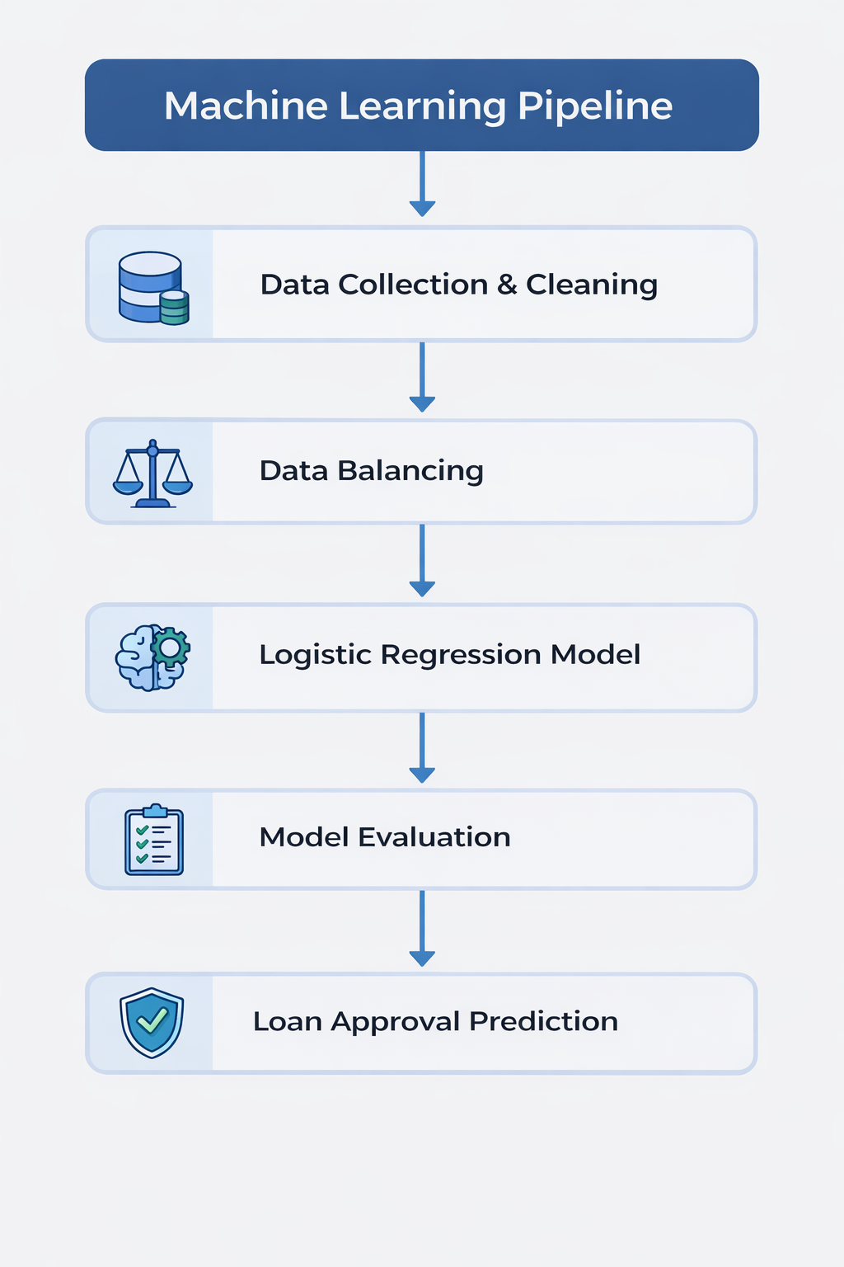
Fig. 1 Sample architecture
- Expected Modules/ Libraries to be used :

1. Pandas
Pandas is used for data manipulation and analysis. It helps in loading, cleaning, filtering, and handling structured data efficiently using DataFrames.

2. NumPy
NumPy is used for numerical computations. It provides support for arrays and mathematical operations, and is used for generating random variations during data augmentation.

3. Matplotlib
Matplotlib is used for data visualization. It helps in creating graphs such as bar plots to analyze class distribution and model results.

4. Seaborn
Seaborn is a statistical data visualization library built on Matplotlib. It provides advanced and visually appealing plots like count plots and heatmaps.

5. Scikit-learn (sklearn)
Scikit-learn is used for implementing machine learning algorithms. It provides tools for data splitting, model training (Logistic Regression), and evaluation metrics.

- Expected Evaluation metrics and Plots to be used:
Evaluation Metrics
To evaluate the performance of the Logistic Regression model, metrics such as Precision, Recall, and F1-score will be used. Since the dataset is imbalanced, accuracy alone may not provide a reliable measure of performance.
1. Precision measures how many of the predicted safe applicants are actually safe.
- Recall measures how many actual safe applicants are correctly identified by the model.
- F1-score provides a balance between precision and recall and is considered the most important metric in this project due to class imbalance.
Additionally, a Confusion Matrix will be used to visualize the number of correct and incorrect predictions made by the model.
Visualization Plots
Various plots will be used to better understand the dataset and model performance.
- Count Plot / Bar Graph: Used to visualize class distribution (safe vs risky applicants) before and after data balancing.
- Confusion Matrix Heatmap: Used to visually represent model performance by showing true positives, true negatives, false positives, and false negatives.

- Required topics from the subject:

1. Strings
Strings are used for handling textual data such as column names and categorical values in the dataset. They help in accessing and filtering data (e.g., selecting columns like "LoanApproved"). String operations are also useful while preprocessing and displaying outputs.

2. Files
File handling is used to read and write data. In this project, the dataset is loaded from a CSV file using file operations, which allows the program to access and process external data.
3. Arrays
Arrays are used to store and manipulate numerical data efficiently. Libraries like NumPy use arrays for performing mathematical operations and handling large datasets.
4. Functions
Functions are used to organize code into reusable blocks. In this project, functions from libraries like sklearn are used for model training, prediction, and evaluation.
5. Data Structures (Lists & Dictionaries)
Lists and dictionaries are used to store and manage data. They help in organizing values, storing results, and handling key-value pairs such as feature names and their corresponding values.
6. Conditional Statements
Conditional statements (if-else) are used for decision-making in code. They help in applying logic such as classifying outputs or handling different conditions during data processing.
7. Loops
Loops are used to iterate over data. They help in performing repetitive tasks such as processing rows of data or applying operations on multiple element

- Platform Required:
The project will be developed using Python in Jupyter Notebook
- Books and Link Sources:
1.Aurélien Géron — Hands-On Machine Learning with Scikit-Learn, Keras, and TensorFlow
(Used for understanding machine learning concepts and model implementation)
2.Tom M. Mitchell — Machine Learning
(Provides fundamental concepts of machine learning algorithms)
3.Scikit-learn Official Documentation
https://scikit-learn.org
(Used for understanding Logistic Regression and evaluation metrics)
4.Pandas Documentation
https://pandas.pydata.org
(Used for data manipulation and preprocessing techniques)
5.Kaggle (Dataset Source)
https://www.kaggle.com
(Used for obtaining the loan dataset and understanding real-world data)

